Abstraction :

Show only necessary thing and hide the unwanted thing.

Real-Life Example of Abstraction

Example: Driving a Car

• When you drive a car, you interact with the steering wheel, accelerator, brake, and gear system. You don’t need to know the internal workings of the engine, fuel injection, or braking system to drive.

• Essential Features (Abstraction):

o Steering to turn the car.

o Accelerator to move forward.

o Brake to stop.

• Hidden Implementation:

o The engine's internal mechanism.

o How fuel is converted into energy.

o Hydraulic systems in the brakes.

1.View of Data (Three Schema Architecture)
  - The major purpose of DBMS is to provide users with an abstract view of the data. That is, the system hides certain details of how the data is stored and maintained.
  - To simplify user interaction with the system, abstraction is applied through several levels of abstraction.

Physical level / Internal level
    - The lowest level of abstraction describes how the data are stored.
    - Low-level data structures used.
    - Talks about: Storage allocation (N-ary tree etc), Data compression encryption,decryption etc.
    - Goal: We must define algorithms that allow efficient access to data.

Logical level / Conceptual level:
    - describes what data are stored in DB, and what relationships exist among those data.
    - User at logical level does not need to be aware about physical-level structures.
    - DBA work on Logical Level.
    - Goal: ease to use.

View level / External level:
    - Each view schema describes the database part that a particular user group is interested and hides the remaining database from that user group.
    - At the external level, a database contains several schemas that sometimes called as
subschema. The subschema is used to describe the different view of the database.
    - At views also provide a security mechanism to prevent users from accessing certain parts of DB.

  - 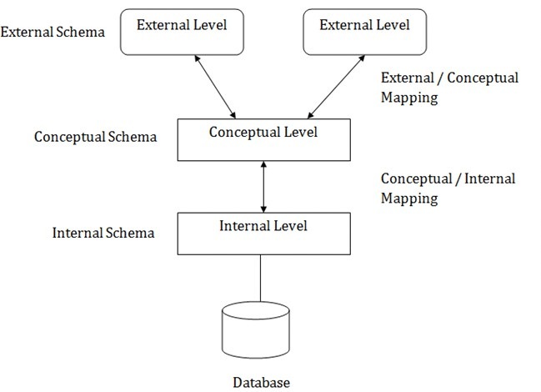

Instances and Schemas
  - The collection of information stored in the DB at a particular moment is called an instance of DB.

- The overall design of the DB is called the DB schema.
- Schema doesn’t change frequently. Data may change frequently.
- We have 3 types of Schemas: Physical, Logical, several view schemas called subschemas.
- Logical schema is most important in terms of its effect on application programs, as programmers construct apps by using logical schema.

- Physical data independence, physical schema change should not affect logical schema/application programs.

Database Languages:
  - Data definition language (DDL) to specify the database schema.
  - Data manipulation language (DML) to express database queries and updates.
  - Practically, both language features are present in a single DB language, e.g., SQL language.
  - DDL

  - DML
  - We specify consistency constraints, which must be checked, every time DB is updated.

- Data manipulation involves
  - Retrieval of information stored in DB.
  - Insertion of new information into DB.
  - Deletion of information from the DB.
  - Updating existing information stored in DB.

How is Database accessed from Application programs?

  - Apps (written in host languages, C/C++, Java) interacts with DB.
  - API is provided to send DML/DDL statements to DB and retrieve the results.
    - Open Database Connectivity (ODBC), Microsoft “C”.
    - Java Database Connectivity (JDBC), Java.

Database Administrator (DBA)
  - A person who has central control of both the data and the programs that access those data.
  - Functions of DBA
    - Database schema
    - Storage structure and access methods.
    - Schema and physical organization modifications.
    - Authorization control.
    - Routine maintenance
      - Periodic backups. : data stored in different server if one server fail access data from another server.

      - Security patches.
      - Any upgrades.
- DBMS Application Architectures: Client machines, on which remote DB users work, and server machines on which DB system runs.
  - T1 Architecture
    - The client, server DB all present on the same machine.

  - T2 Architecture
    - App is partitioned into 2-components.
    - Client machine, which invokes DB system functionality at server end through query language statements.
    - API standards like ODBC JDBC are used to interact between client and serve
C.T3 Architecture

    - App is partitioned into 3 logical components.
    - Client machine is just a frontend and doesn’t contain any direct DB calls.
    - Client machine communicates with App server, and App server communicated with DB system to access data.
    - Business logic, what action to take at that condition is in App server itself.
    - T3 architecture are best for WWW Applications.

Advantages:
      - Scalability due to distributed application servers.
      - Data integrity, App server acts as a middle layer between client and DB, which minimize the chances of data corruption.
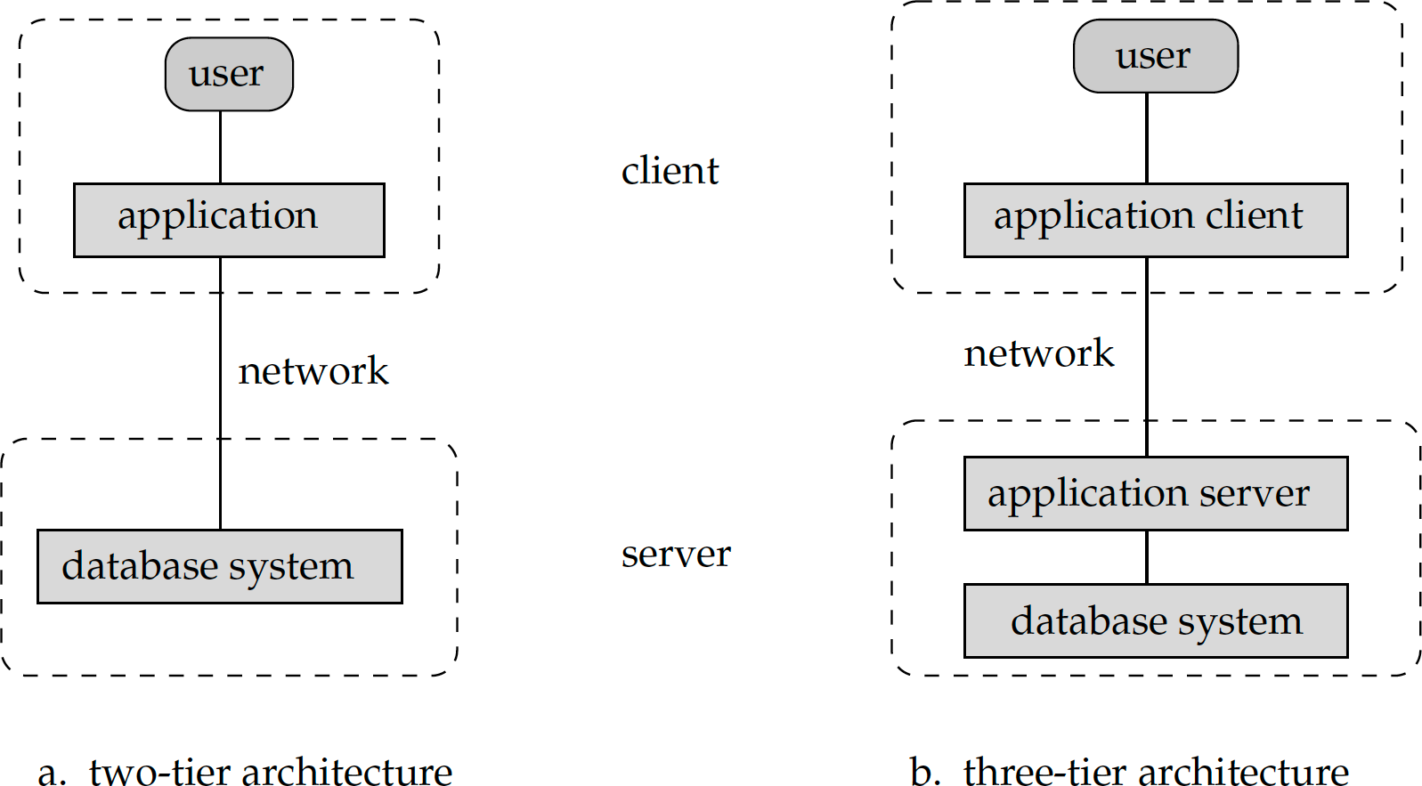
      - Security, client can’t directly access DB, hence it is more secure.

